Contents

CLOUD COMPUTING 3

CLOUD PRICING 3

OSI MODEL 3

SERVER TYPES 4

BACKGROUND OF CLOUD COMPUTING 4

ISSUES WITH IN-PREMISE INFRASTRUCTURE 4

ECONOMY OF CLOUD COMPUTING 4

SOLUTION OF ISSUES OF IN-PREMISE INFRASTRUCTURE 5

VIRTUALIZATION 5

VIRTUALIZED ENVIRONMENT 6

BENEFITS OF VIRTUALIZATION 6

TYPES OF HYPERVISORS 6

CLOUD CONCEPTS 7

WHAT IS CLOUD COMPUTING 7

SHARED RESPONSIBILITY MODEL 7

ON-PREM 8

IAAS 9

PAAS 9

SAAS 11

BENEFITS OF CLOUD 12

HIGH AVAILABILITY 12

SCALABILITY 13

ELASTICITY 13

RELIABILITY - FAULT TOLERANCE/DISASTER RECOVERY 13

PREDICTABILITY 14

SECURITY 14

GOVERNANCE 14

MANAGEABILITY 15

AGILITY 15

GEO-DISTRIBUTION: 15

TYPES OF CLOUD MODELS 16

SERVICE MODELS 16

DEPLOYMENT MODELS 20

WHAT IS SERVERLESS COMPUTING? 22

HOW AZURE WORKS? 23

AZURE INFRASTRUCTURE SET UP 24

DIFFERENT WAYS OF ACCESSING AZURE PLATFORM 24

POWERSHELL 24

AZURE CLI 27

AZURE CLI AND POWERSHELL COMMAND PATTERN 28

CORE ARCHITECTURAL COMPONENTS 28

AZURE REGIONS 28

WHY REGION IS IMPORTANT 29

SELECTING A REGION 29

AZURE REGION PAIR 29

SOVEREIGN REGION 30

AZURE AVAILABILITY ZONE 31

REGION AND ZONE 32

TYPES OF AVALIBILITY ZONE SERVICES 32

RESOURCES AND RESOURCE GROUP 32

RESOURCES 32

RESOURCE GROUP 33

SUBSCRIPTION 35

TYPES OF AZURE SUBSCRIPTION 35

MANAGEMENT GROUP 35

MANAGING / CREATING BUDGET 37

SETTING UP BUDGET 37

RESOURCE LOCKING 38

AZURE RESOURCE MANAGER (ARM) 39

HOW ARM WORKS? 39

AZURE SERVICES 40

COMPUTE SERVICES 41

NETWORKING 41

STORAGE SERVICE 43

DATABASE 44

AZURE CORE SERVICES 44

AZURE COMPUTE SERVICES 45

AZURE NETWORK SERVICES 46

AZURE VIRTUAL NETWORK 46

# CLOUD COMPUTING

## CLOUD PRICING

Cloud pricing can vary depending on several factors. Here are some of the key factors that can impact cloud pricing:

* SERVICE TYPE:
  + Different cloud services, such as Infrastructure as a Service (IaaS), Platform as a Service (PaaS), and Software as a Service (SaaS), have different pricing models and cost structures.
* RESOURCE USAGE
  + The amount of resources used, such as compute power, storage, bandwidth, and network traffic, can impact pricing. Providers often charge based on the quantity of resources consumed, typically measured by the hour, gigabyte, or other relevant units.
* SERVICE LEVEL AGREEMENTS (SLAS):
  + Higher levels of service availability and performance can come at a higher cost.
  + Providers may offer different SLA tiers with varying levels of uptime guarantees and support.
* GEOGRAPHIC REGION
  + The location where the cloud services are consumed or hosted can affect pricing.
  + Providers may have different pricing structures based on the region or data center location.
* INSTANCE TYPE
  + Cloud providers often offer various instance types with different performance characteristics and pricing. Instances with higher computing power or specialized features may be more expensive.
* CONTRACT TERMS
  + Longer-term commitments or contracts with providers can often lead to discounted pricing.
  + Providers may offer reserved instances or other pricing models for customers who commit to using their services for a certain duration.
* ADDITIONAL SERVICES
  + Cloud providers offer a range of additional services, such as data analytics, machine learning, or database services, which may have separate pricing structures.

## OSI MODEL

**The Open Systems Interconnection (OSI) model describes seven layers that computer systems use to communicate over a network.**

|  |  |
| --- | --- |
| Layers of OSI Model - GeeksforGeeks |  |



## SERVER TYPES

* Rack Servers
* Tower Servers
* Blade Servers

# BACKGROUND OF CLOUD COMPUTING

## ISSUES WITH IN-PREMISE INFRASTRUCTURE

When we must set up a on premise infrastructure. There are multiple factors which we need to account for

1. **COST(EXPENDITURE) -**High CapEx and OpEx
2. **MAINTENANCE -** Hardware and Software maintenance
3. **SCALABILITY –** For scalability – the in-premise set up has to make sure that they have enough infrastructure available (processing power, Storage capacity etc..) to meet the high demand.

### ECONOMY OF CLOUD COMPUTING

There are two different types of expenses that we should consider:

#### **CAPITAL EXPENDITURE (CAPEX)**

* Capital Expenditure – is the money we pay money upfront.

EXAMPLES OF CAPEX

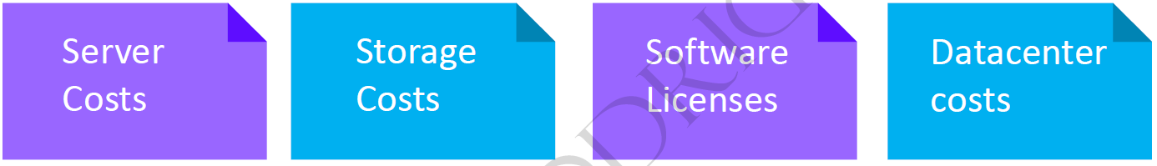

#### **OPERATIONAL EXPENDITURE (OPEX)**

* It the ongoing money spent on services Example - Running cost of VM

EXAMPLES OF OPEX

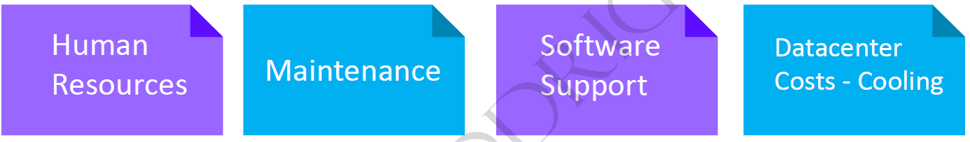

***To summarize, CapEx requires significant up-front financial costs, as well as ongoing maintenance and support expenditures. By contrast, OpEx is a consumption-based model, so we are only responsible for the cost of the computing resources that we use****.*

#### CLOUD COMPUTING IS A CONSUMPTION-BASED MODEL

Cloud service providers operate on a **consumption-based model**, which means that end users only pay for the resources that they use. Whatever they use is what they pay for.

A consumption-based model has many benefits, including:

* No upfront costs.
* No need to purchase and manage costly infrastructure that users might not use to its fullest.
* The ability to pay for additional resources when they are needed.
* The ability to stop paying for resources that are no longer needed.

## SOLUTION OF ISSUES OF IN-PREMISE INFRASTRUCTURE

To solve the issue, we have in premise infrastructure – industry moved towards a technology called **Virtualization**. The problem can be solved by setting up highly virtualized environment.

## VIRTUALIZATION



* Virtualization is the process of running a virtual instance of a computer system in a layer abstracted from the actual hardware. Most commonly, it refers to running multiple operating systems on a computer system simultaneously.
* To the applications running on top of the virtualized machine, it can appear as if they are on their own dedicated machine, where the operating system, libraries, and other programs are unique to the guest virtualized system and unconnected to the host operating system which sits below it.

**Note: The machine on which VM are created are called HOST MACHINE and all the VM are called GUEST MACHINE.**

* For administrators of servers, virtualization also offers the ability to run different operating systems, but perhaps, more importantly, it offers a way to segment a large system into many smaller parts, allowing the server to be used more efficiently by several different users or applications with different needs. It also allows for isolation, keeping programs running inside of a virtual machine safe from the processes taking place in another virtual machine on the same host.

### VIRTUALIZED ENVIRONMENT

|  |  |
| --- | --- |
|  | * In a highly virtualized environment – when have 2 or more physical servers connected to SAN (Storage Area Network). Collectively they are called Cluster * Each physical hardware is virtualized using a software called hypervisor (Type 1 or Type 2) * To manage the cluster – we need a Cluster Management Software which is installed on a dedicated server. * These cluster management software provides an interface (Portals) to manage the storage, VM, network etc.. * The examples of Cluster Management software are System Center, OpenStack, or VMWare vSphere Suite.   **THIS ENTIRE SET UP IS CALLED PRIVATE CLOUD** |

### BENEFITS OF VIRTUALIZATION

* BETTER RESOURCE UTILIZATION
* LOWERS THE COST OF RESOURCES.
* ENABLE REMOTE ACCESS
* PAY AS YOU GO.
* ENABLE RUNNING MULTIPLE OS

### TYPES OF HYPERVISORS

#### TYPE-1 HYPERVISOR

* The hypervisor runs directly on the underlying host system. It is also known as a “**Native Hypervisor” or “Bare metal hypervisor**”. It does not require any base server operating system. It has direct access to hardware resources. Examples of Type 1 hypervisors **include VMware ESXi, Citrix XenServer, and Microsoft Hyper-V hypervisor**.
* Such kinds of hypervisors are very efficient because they have direct access to the physical hardware resources (like CPU, Memory, Network, and Physical storage). This causes the empowerment of the security because there is nothing any kind of the third-party resource so that attacker couldn’t compromise with anything.
* One problem with Type-1 hypervisors is that they usually need a dedicated separate machine to perform their operation and to instruct different VMs and control the host hardware resources.

#### TYPE-2 HYPERVISOR

* A Host operating system runs on the underlying host system. It is also known as ‘**Hosted Hypervisor**”. Such kind of hypervisors doesn’t run directly over the underlying hardware rather they run as an application in a Host system (physical machine). Basically, the software is installed on an operating system. Hypervisor asks the operating system to make hardware calls. **An example of a Type 2 hypervisor includes VMware Player or Parallels Desktop.**
* Such kind of hypervisors allows quick and easy access to a guest Operating System alongside the host machine running. These hypervisors usually come with additional useful features for guest machines. Such tools enhance the coordination between the host machine and the guest machine.
* Here there is no direct access to the physical hardware resources so the efficiency of these hypervisors lags in performance as compared to the type-1 hypervisors, and potential security risks are also there an attacker can compromise the security weakness if there is access to the host operating system so he can also access the guest operating system.

**Type 1 hypervisors offer much better performance than Type 2 ones because there’s no middle layer, making them the logical choice for mission-critical applications and workloads.**

# CLOUD CONCEPTS

To understand what cloud computing concept, we is needed to understand the problem - it is solving for a traditional applications

|  |  |
| --- | --- |
| **SCALABILILTY** | * For a tradition application we need to increase hardware as user demand increases. * Need to increase staff to maintain the server * **Cloud computing: It helps in scaling up / down to meet the demand hence can able to solve the scalability issues.** |
| **COST** | * High upfront expenses and capital expenditure; high maintenance cost * **Cloud computing - User has to pay only for the resources they use** |
| **MAINTENANCE** | * Servers need to be managed and monitored continuously * **Cloud Computing: Servers are maintained by the cloud providers** |
| **SLOW DATA RECOVERY** | * Takes more time to recover data; requires high budget and resources * **Cloud Computing : Fast data recovery and automated data backup** |

## WHAT IS CLOUD COMPUTING



1. **It's the delivery of computing services over the internet, which is otherwise known as the cloud.** These services include **servers, storage, databases, networking, software, analytics, and intelligence.** Cloud computing offers faster innovation, flexible resources, and economies of scale.
2. Cloud computing is the delivery of computing services over the internet by using a pay-as-you-go pricing model. You typically pay only for the cloud services you use, which helps you:

* Lower your operating costs.
* Run your infrastructure more efficiently.
* Scale as your business needs change.

To put it another way, cloud computing is a way to rent compute power and storage from someone else's datacenter. You can treat cloud resources like you would resources in your own datacenter. When you're done using them, you give them back. You're billed only for what you use. Instead of maintaining CPUs and storage in your datacenter, you rent them for the time that you need them. The cloud provider takes care of maintaining the underlying infrastructure for you.

## SHARED RESPONSIBILITY MODEL

*In the context of cloud computing, the shared responsibility model defines the division of responsibilities between the cloud service provider (CSP) and the customer. While the exact responsibilities may vary depending on the specific CSP and service being used, the general principles are as follows:*

CSP RESPONSIBILITIES

* The cloud service provider is responsible for the security and maintenance of the underlying cloud infrastructure, including the physical servers, networking, and data centers.
* They are also responsible for ensuring the availability, scalability, and performance of the cloud services they provide.

CUSTOMER RESPONSIBILITIES

The customer is responsible for managing and securing the data and applications they store or run on the cloud platform. This includes tasks such as:

* + DATA SECURITY: Customers are responsible for implementing appropriate access controls, encryption, and data protection measures to safeguard their data.
  + APPLICATION SECURITY: Customers are responsible for securing their applications by applying necessary security patches, configuring firewalls, and implementing secure coding practices.
  + IDENTITY AND ACCESS MANAGEMENT (IAM): Customers are responsible for managing user access to their cloud resources, defining roles and permissions, and ensuring proper authentication and authorization.
  + COMPLIANCE AND GOVERNANCE: Customers must adhere to relevant regulatory requirements and industry standards applicable to their data and applications, including data privacy and protection regulations.
  + BACKUP AND DISASTER RECOVERY: Customers are typically responsible for implementing backup and disaster recovery solutions for their data and applications hosted on the cloud.
  + MONITORING AND LOGGING: Customers should monitor their cloud resources, set up appropriate logging, and analyze logs for security and performance-related insights.

**THE SPECIFICS OF SHARED RESPONSIBILITY MAY VARY DEPENDING ON THE CLOUD SERVICE MODEL BEING USED (IAAS, PAAS, OR SAAS.)**

|  |  |
| --- | --- |
| * In general, the CSP is responsible for securing the cloud infrastructure, including the physical data centers, network infrastructure, and hypervisors. * They also take care of ensuring the availability, scalability, and performance of the cloud services. | * On the other hand, the customer is responsible for securing their data and applications that they deploy on the cloud. * This includes tasks such as managing access controls, configuring firewalls, implementing encryption, and applying security patches to their virtual machines or applications. |

### ON-PREM

IN ON PREM ENVIRONMENT – We are responsible for everything, which includes.

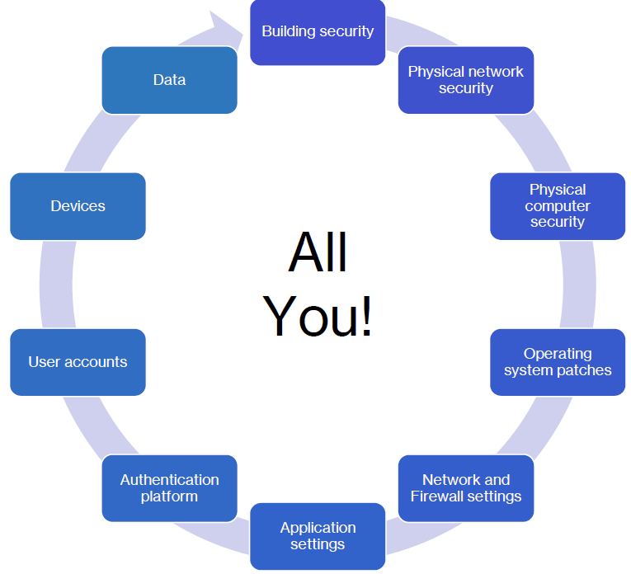

* **So one of the benefits of the cloud model is that we can able to hand off some of the responsibilities to a cloud provider like Azure**

### IAAS

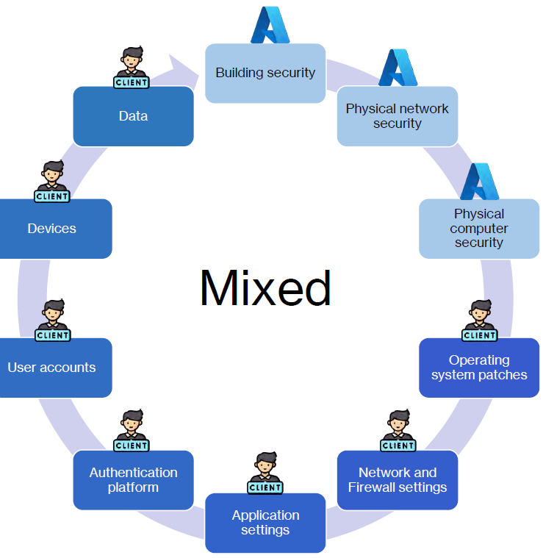

### PAAS

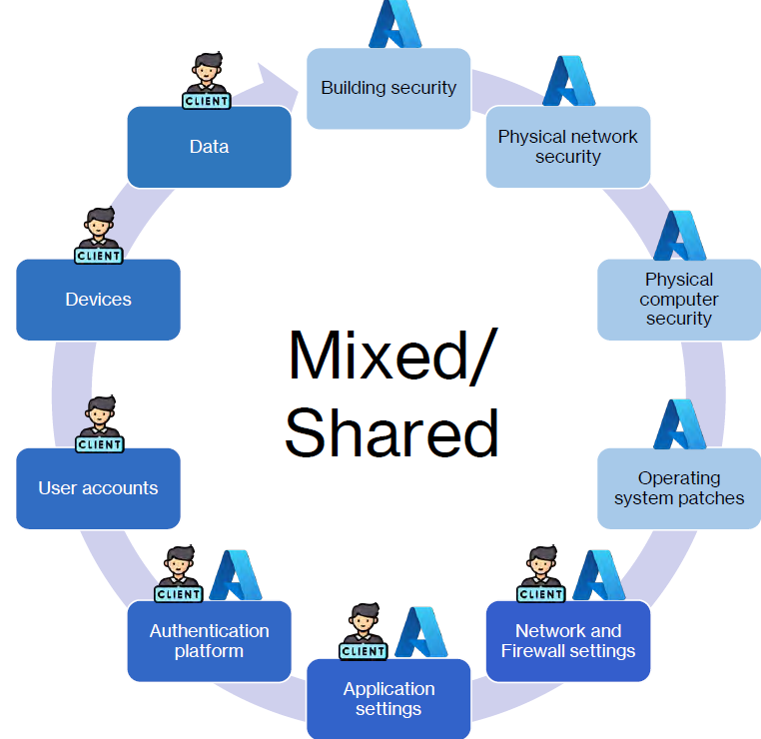

### SAAS

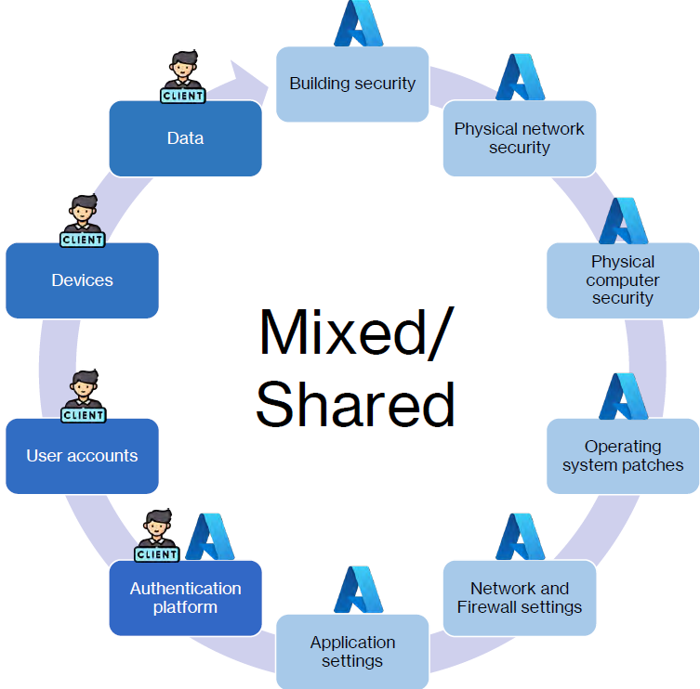

IN AS A SUMMARY

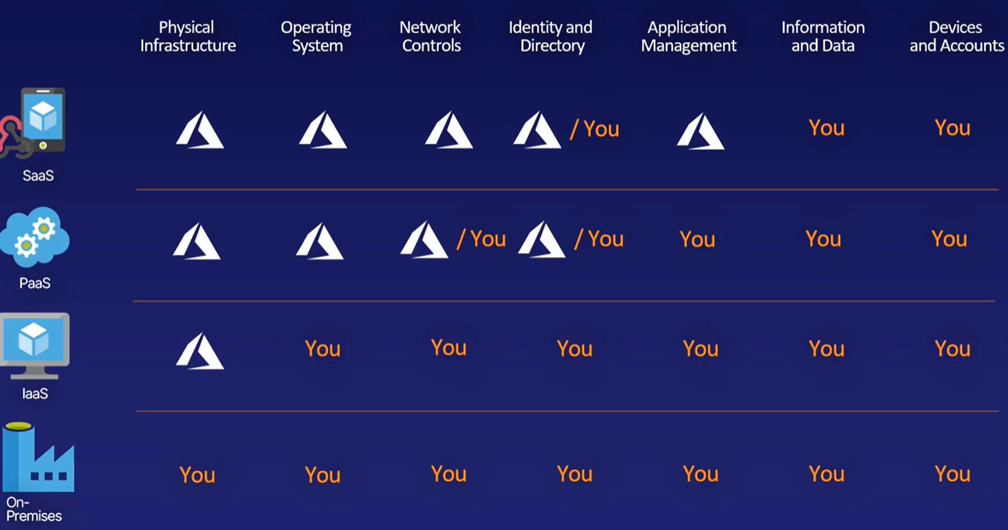

## BENEFITS OF CLOUD

### **HIGH AVAILABILITY**

* **Ability of a system to remain operational to users during planned or unplanned outage.**
  + For Planned outages are predictable and timing can be controlled.

|  |  |
| --- | --- |
| **EXAMPLES OF PLANNED OUTAGES** | **METHODS TO MITIGATE PLANNED OUTAGES** |
| * OPERATING SYSTEM/ DB SECURITY PATCHES * APPLICATION UPDATES * HARDWARE REPLACEMENT * MIGRATING TO A NEW HOSTING PROVIDER | * GRADUAL DEPLOYMENT STRATEGY * TESTING AND MONITORING OF DEPLOYMENT * EASY ROLLBACK PLAN * SMALL DEPLOYMENTS * FREQUENT DEPLOYMENTS * AUTOMATION |

|  |  |
| --- | --- |
| **EXAMPLES OF UNPLANNED OUTAGES** | **METHODS TO MITIGATE PLANNED OUTAGES** |
| * HARDWARE FAILURE * NETWORK DISRUPTIONS * POWER OUTAGES * NATURAL DISASTERS * HUMAN ATTACK - CYBER ATTACKS * SOFTWARE BUGS * POOR SCALING / ARCHITECTURE DESIGN | * REDUNDANCY OF CORE COMPONENTS * USE AZURE’S BUILT-IN FEATURES FOR AVAILABILITY   + AVAILABILITY SETS   + AVAILABILITY ZONES   + CROSS-REGION LOAD BALANCING / FRONT DOOR * CONSTANT HEALTH MONITORING / PROBES * AUTOMATION LIKE   + REBOOT AND ADDING ADDITIONAL SERVERS   + FALLBACK STRATEGIES * STRONG SECURITY PRACTICES * BE GEOGRAPHICALLY DISTRIBUTED * HAVE A DISASTER RECOVERY PLAN AND TEST DISASTER RECOVERY PLAN * LOAD TESTING |

* + The examples of Planned outages
* Depending on the service-level agreement (SLA) that we choose, the cloud-based apps can provide a continuous user experience with no apparent downtime, even when things go wrong.
* **FOR VITUAL MACHINE**
  + *If the application hosted on virtual machines- for high availability, we could make those VMs either part of an availability set or an availability zone.*
  + *To protect against physical server failures or rack failures we make use of availability sets.*
  + *To protect against data center level failures, we can make use of availability zones.*
* **FOR STORAGE ACCOUNT**
  + *To protect the data against data center level failures, we can make use of zone-redundant storage.*
  + *For protection against region level failures, we can make use of geo-redundant storage as a data redundancy option.*

### **SCALABILITY**

**The ability of a system to accommodate increasing demand by adding or removing resources as needed.**

WHY WE NEED SCALABILITY

* It allows a system to adapt to changing usage patterns and handle increased traffic without requiring changes to the application code or system design.
* Apps in the cloud can scale vertically and horizontally:
  + VERTICALLY SCALING:
    - Also called “scaling up” or “scaling down”
    - Adding more resources to a single server
    - Increase the amount of memory, the number of CPUs
    - There is an upper limit to this. In Azure we can go up to –96 vCPUs, 384 GB memory
  + HORIZONTAL SCALING:
    - Also called “scaling out” or “scaling in”
    - Process of adding more servers to a system
    - No limits to Horizontal scaling
    - This can add complexities for load balancing
* *Example – For scalability in VM we can make use of Availability Set*
* *For scalability in storage account – the size keeps growing, if we keep uploading data in the storage account.*

### ELASTICITY

**The ability of a system to quickly and easily scale up or down the number of resources that a system uses in response to changing demand**

Elasticity should happen very quickly, for that.

* We need to involve some sort of automation.
* Elasticity is often called “autoscaling” in cloud computing. In autoscaling - The system monitors some metric (such as CPU utilization) to determine how busy a system is, then adds resources when it exceeds a limit for being busy and remove resources when it falls below a limit for being not busy

**BENEFITS**

* More efficient and cost-effective use of resources
* Minimizes computing “waste” –resources paid for and not used

### RELIABILITY **- FAULT TOLERANCE/DISASTER RECOVERY**

* **The ability of a system to perform its intended function without interruption and with a high degree of accuracy.**
* **The cloud system is reliable even if things go wrong and can quickly recover as a result.**

#### AVAILABILITY VS RELIABILITY

* A system can be highly available to users and responds instantly to every request. However - The system itself might be highly unreliable. Example: A calculator that can answer every question with the wrong answer? i.e. an running app does not behave as expected like loses the data sometimes randomly?

#### HOW TO ACHIEVE RELIABILITY?

* + AUTO-SCALING
  + MULTI-REGION DEPLOYMENTS
  + DATA BACKUP AND REPLICATION
  + HEALTH PROBES AND SELF-HEALING

*By taking advantage of cloud-based backup services, data replication, and geo-distribution, we can deploy our apps with the confidence that comes from knowing that the data is safe in the event of disaster.*

### PREDICTABILITY

* The ability to forecast and control the performance and behavior of a system
* This includes the ability to predict future costs
  + **PREDICTABLE PERFORMANCE**
    - Predictable performance is knowing that the application is going to have the same experience for our customers regardless of how many of our customers are on that application at any given point of time.
    - This is closely intertwined high availability and scalability.
  + **PREDICTABLE COSTS.**
    - Azure allows us to both track and forecast in real-time - what resources we are using and what we are going to pay.
    - Azure provides several analytics tools. Viewing the patterns over time so we can accurately predict long term cloud usage as well.

#### HOW TO ACHIEVE PREDICTABILITY?

* AUTOSCALING
* LOAD BALANCING
* DIFFERENT INSTANCE TYPES, SIZES, PRICING TIERS
* COST MANAGEMENT TOOLS IN PORTALS
* API
  + There are APIs for budgeting, so if we want to download our spending and usage in an external system using some kind of automated programming to report on costs.
* PUBLICALLY AVAILABLE PRICING CALCULATORS

### **SECURITY**

* In the shared responsibility model, the security is shared responsibility between Microsoft and the customer. Microsoft does their part on the things they control, and they help us to do our part on the things that we control.

#### HOW TO ACHIEVE SECURITY?

* INDUSTRY STANDARD COMPLIANCE CERTIFICATIONS
  + Microsoft follow certain ISO and other international standards for security compliance.
* MICROSOFT SECURITY RESPONSE CENTER (MSRC)
  + Microsoft has the security response center (MSRC). It is a team of people working in their data centers
  + They monitor the network looking for suspicious traffic, to make sure that there is a basic level of security across the Microsoft global network.
* ALWAYS-ON DDOS (DENIAL OF SERVICE PROTECTION)
* AZURE POLICY & BLUEPRINT (GOVERNANCE SERVICES)
* ROLE BASED ACCESS CONTROL (RBAC)
* AZURE ACTIVE DIRECTORY
* ALWAYS UP-TO-DATE PLATFORM SERVICES
* UPDATE MANAGEMENT
* ENCRYPTION BY DEFAULT
  + ENCRYPTION AT REST – USING DISK ENCRYPTION
  + ENCRYPTION IN TRANSIENT– HTTPS AND SSL
* MULTIPLE SECURITY SERVICES LIKE FIREWALL

### GOVERNANCE

* Governance How your organization does business
* **The process of defining, implementing, and monitoring a framework of policies that guides an organization's cloud operations.**
* Governance is the ability or the capability to establish corporate standards for our different Azure deployed environments, including restrictions on deployed resources when necessary.
* These allow us to create standardized environments that uphold to a corporate standard.

#### WHY WE NEED GOVERNANCE?

* Company wants to ensure its policies are followed in the cloud which can be done using basic auditing and reporting, as well as enforcement.
* The example of basic governance can be
  + To know what resources are being created, who created them, when they were created,
  + Able to stop certain operations or stop certain types of resources from being created.
  + Putting an upper limit on the cost of a resource,
* To be compliant with industry standards such as HIPPA or PCC or GDPR

#### HOW TO ACHIEVE GOVERNANCE?

* AZURE POLICY & BLUEPRINT
* MANAGEMENT GROUPS
  + The company can have multiple subscriptions, which can be hierarchical.
  + Management groups allow us to manage our subscriptions and apply policies to certain groups that apply to all subscriptions under that group.
* CUSTOM ROLES
* SOFT DELETE
* GUIDES AND BEST PRACTICES SUCH AS CLOUD ADOPTION FRAMEWORK

#### AZURE POLICY AND BLUEPRINT

Azure Policy and Azure Blueprint are two distinct services provided by Microsoft Azure that help in managing and governing cloud resources effectively.

* AZURE POLICY
  + Azure Policy is a service that allows organizations to enforce compliance and governance policies for their Azure resources.
  + It provides a set of rules and policies that define certain conditions, requirements, and restrictions on how resources should be configured and used within an Azure subscription or management group.
  + Azure Policy helps in maintaining consistency, security, and compliance by automatically evaluating and enforcing these policies across the Azure environment.
* AZURE BLUEPRINT
  + Azure Blueprint is a service that helps in streamlining the process of deploying and managing cloud environments that adhere to organizational standards, compliance requirements, and best practices.
  + Azure Blueprints provide a declarative and repeatable way to define and deploy a set of Azure resources, including policies, roles, resource groups, and more, as a single unit.

### MANAGEABILITY

* + **MANAGEMENT OF THE CLOUD** 
    - Management of the cloud refers -to how we manage different cloud resources, which can include automatically scaling of resources up and down
    - Having full visibility into the health of our resources via the monitoring tools built into Azure, which can include automatically replacing failing resources
    - Ability to deploy resources in preconfigured templates such as ARM templates,
  + **MANAGEMENT IN THE CLOUD**.
    - Management in the cloud refers to how we are able to manage and interact with our different cloud resources, which can include the Azure Portal, Cloud Shell, Azure CLI, PowerShells and APIs

### **AGILITY**

* Deploy and configure cloud-based resources quickly as our app requirements change.

### **GEO-DISTRIBUTION**:

* We can deploy apps and data to regional datacenters around the globe, thereby ensuring that the customers always have the best performance in their region.

## TYPES OF CLOUD MODELS



### SERVICE MODELS

These models define the different levels of shared responsibility that a cloud provider and cloud tenant are responsible for.

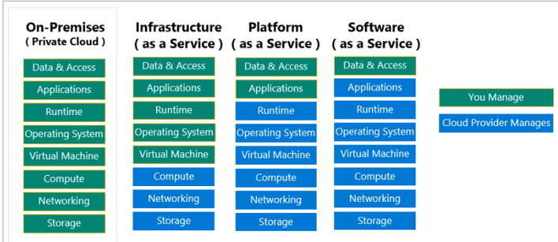



|  |  |
| --- | --- |
| MODEL | DESCRIPTION |
| **Iaas**  (Infrastructure-as-a-Service) | * **Cloud provider manages the hardware- but operating system maintenance and network configuration are managed by us.** * On Azure, the IaaS offering includes virtual machines, storage, networking components and firewall |
| **PaaS**  (Platform-as-a-Service) | * The cloud provider manages the virtual machines and networking resources, and the cloud tenant deploys their applications into the managed hosting environment. * For example, Azure App Services provides a managed hosting environment where developers can upload their web applications, without having to worry about the physical hardware and software requirements. * **PaaS includes infrastructure - service, storage, and networking but also middleware, development tools, business intelligence (or BI),services, database management systems,** * PaaS is designed to support the complete web application lifecycle: building, testing,deploying, managing, and updating. * On Azure, the PaaS offering avoids the expense and complexity of buying and managing software licenses, the underlying application infrastructure, and middleware. * We manage the applications and services that you develop,and the cloud service provider typically manages everything else. Example - **security features,development tools, and data warehouse services.** |
| **SaaS**  **(**Software-as-a-Service**)** | * The cloud provider manages all aspects of the application environment, such as virtual machines, networking resources, data storage, and applications. * The cloud tenant only needs to provide their data to the application managed by the cloud provider. * For example, Microsoft Office 365 provides a fully working version of Microsoft Office that runs in the cloud. All we need to do is create our content, and Office 365 takes care of everything * **Azure SQL Server and Azure Active Directory are all examples of SaaS offerings on Azure.** |
| **SERVERLESS** |  |

#### IAAS

* Most flexible category of cloud services.
* Consumer will have complete control over the hardware that run applications.
* Instead of buying hardware, with IaaS, we rent it from a CSP

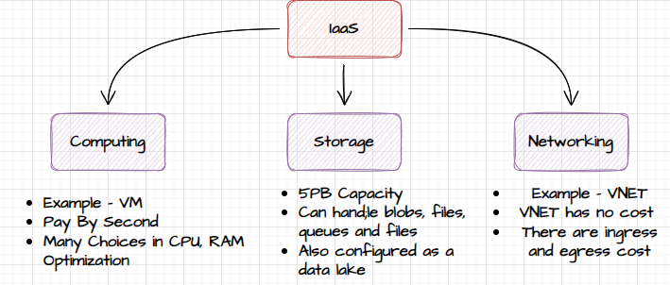

#### ADVANTAGES

* **NO CAPEX**
  + Users have no up-front costs.
* **AGILITY**
  + Applications can be made accessible quickly, and deprovisioned whenever needed.
* **MANAGEMENT**
  + The shared responsibility model applies; the user manages and maintains the services they have provisioned, and the cloud provider manages and maintains the cloud infrastructure.
* **CONSUMPTION-BASED MODEL**
  + Organizations pay only for what they use and operate under an Operational Expenditure (OpEx) model.
* **FLEXIBILITY**
  + IaaS is the most flexible cloud service because we have control to configure and manage the hardware running your application.

#### PAAS

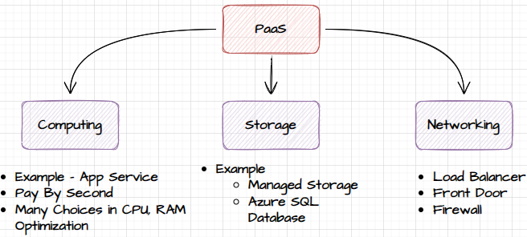

##### ADVANTAGES

* **NO CAPEX**
  + Users have no up-front costs.
* **AGILITY**
  + PaaS is more agile than IaaS, and users don't need to configure servers for running applications.
* **CONSUMPTION-BASED MODEL**
  + Users pay only for what they use, and operate under an OpEx model.
* **PRODUCTIVITY**
  + Users can focus on application development only, because the cloud provider handles all platform management.

#### SAAS

* SaaS is software that's centrally hosted and managed for consumers .
* One version of the application is used for all customers, and it's licensed through a monthly or annual subscription.

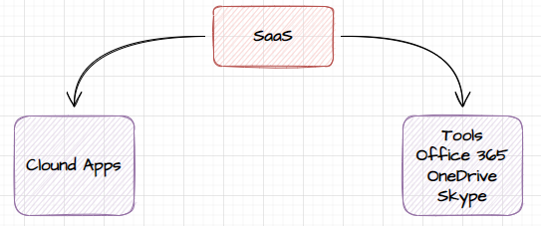

##### ADVANTAGES

* **NO CAPEX**
  + Users have no up-front costs.
* **AGILITY**
  + Users can provide staff with access to the latest software quickly and easily.
* **PAY-AS-YOU-GO PRICING MODEL**
  + Users pay for the software they use on a subscription model
* **FLEXIBILITY**
  + Users can access the same application data from anywhere.

##### DISADVANTAGE

* **SOFTWARE LIMITATIONS**
* We don't have direct control of features.

#### CLOUD SERVICE MODEL COMPARISON

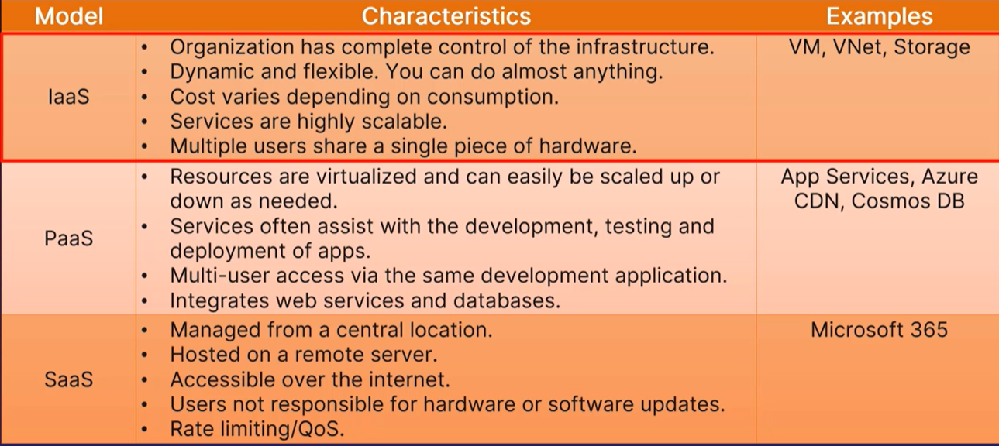



### DEPLOYMENT MODELS

#### PUBLIC CLOUD

* Services are offered over the public internet and available to anyone who wants to purchase them. Cloud resources, such as servers and storage, are owned and operated by the cloud service provider.

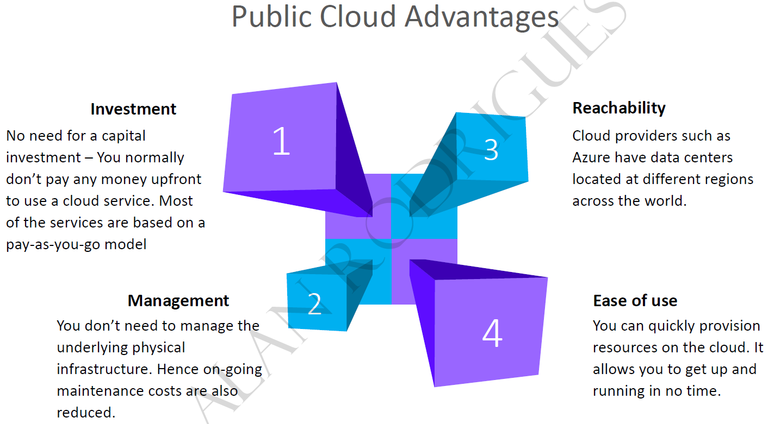

#### PRIVATE CLOUD

* A private cloud consists of computing resources used exclusively by users from one business or organization. A private cloud can be physically located at the organization's on-site (on-premises) datacenter.

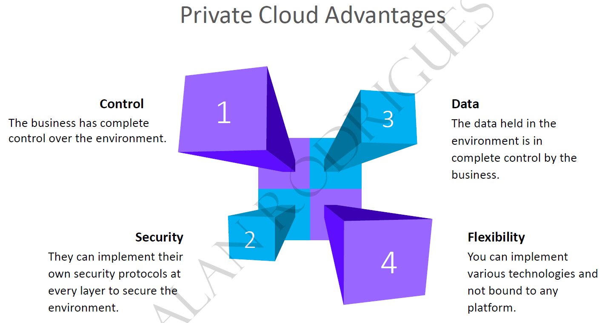

#### HYBRID CLOUD

* A hybrid cloud is a computing environment that combines a public cloud and a private cloud by **allowing data and applications to be shared between them**.

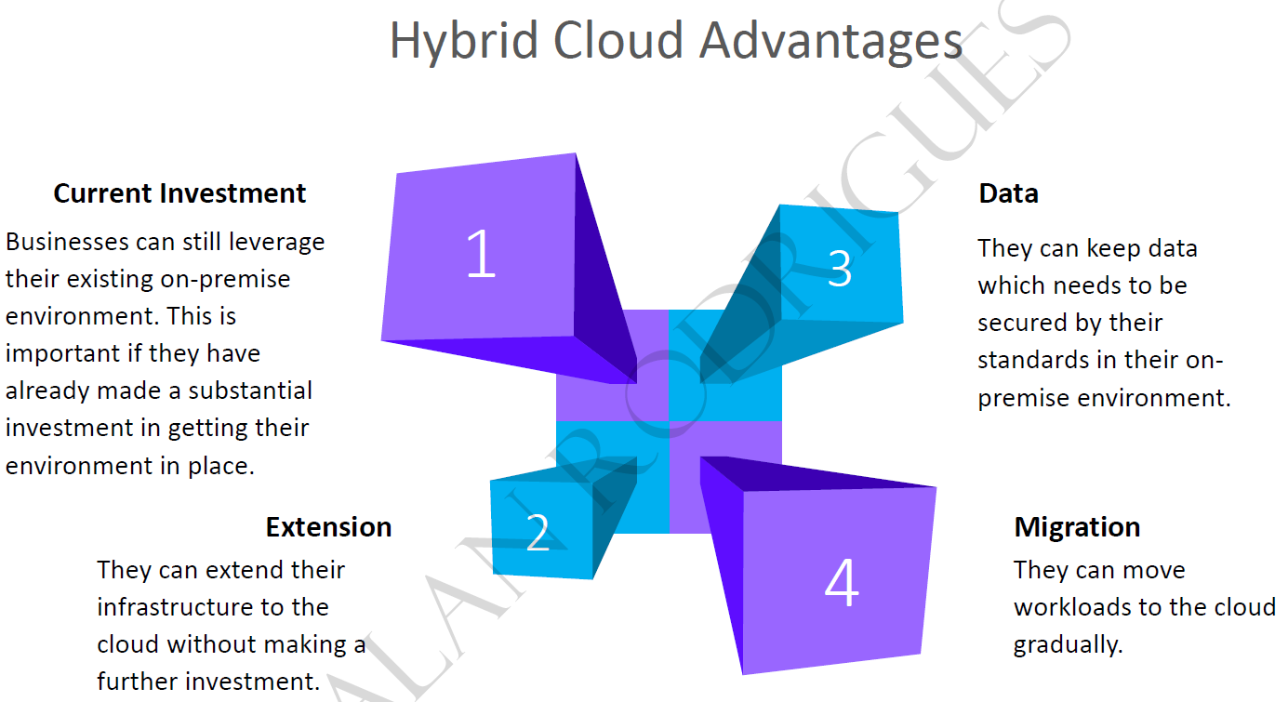

### WHAT IS SERVERLESS COMPUTING?

* Like PaaS, serverless computing enables developers to build applications faster by eliminating the need for them to manage infrastructure.
* With serverless applications, the cloud service provider automatically provisions, scales, and manages the infrastructure required to run the code.
* Serverless architectures are highly scalable and event-driven, only using resources when a specific function or trigger occurs.
* It's important to note that servers are still running the code. The "serverless" name comes from the fact that the tasks associated with infrastructure provisioning and management are invisible to the developer. This approach enables developers to increase their focus on the business logic and deliver more value to the core of the business.
* Serverless computing helps teams increase their productivity and bring products to market faster, and it allows organizations to better optimize resources and stay focused on innovation.
* Function App are example of serverless model.
* For Serverless s- consumers are paying for service not for renting hardware

#### TYPES OF SERVLESS SERVICES

1. FUNCTION APPS
2. CONTAINER APPS
3. KUBERNETES
4. SQL DATABASE
5. COSMOS DB

##### FUNCTION APPS

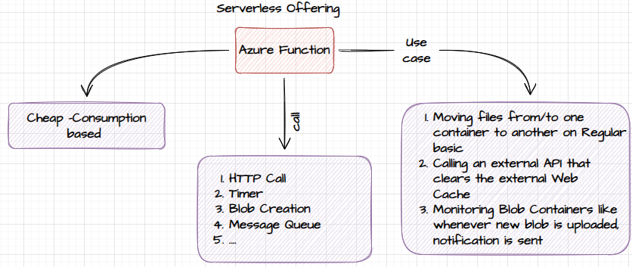

## HOW AZURE WORKS?

* Azure uses a technology known as **virtualization**. ***Virtualization separates the tight coupling between a computer's hardware and its operating system, using an abstraction layer called a hypervisor***.
* The hypervisor emulates all the functions of a real computer and its CPU in a virtual machine, optimizing the capacity of the obstructed hardware. It can run multiple virtual machines at the same time, and each virtual machine can run any compatible operating system, such as Windows or Linux.
* Azure takes this virtualization technology and repeats it on a massive scale in Microsoft data centers throughout the world. Each data center has mini racks filled with servers, and each server includes a hypervisor to run multiple virtual machines.

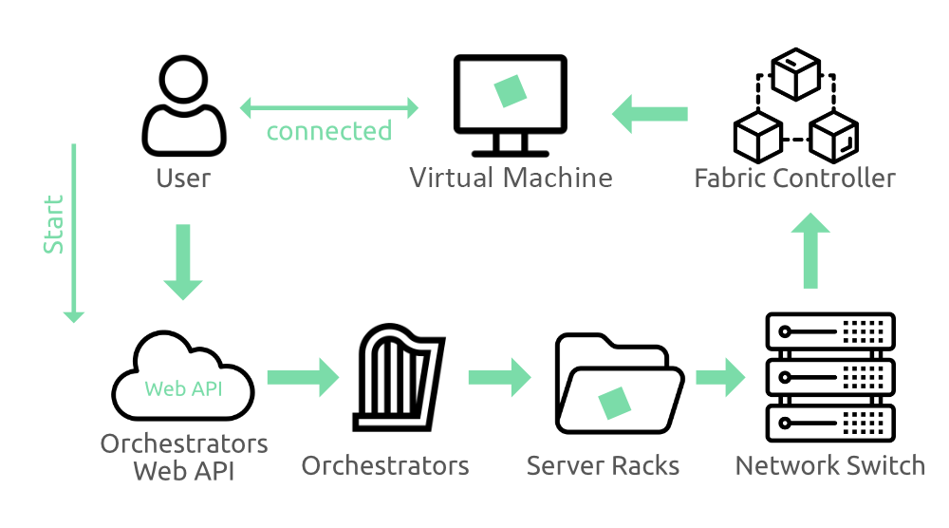

* A network switch provides connectivity to all those servers. One server in each rack runs a special piece of software called a fabric controller. Each fabric controller is connected to another special piece of software known as the Orchestrator.
* The orchestrator is responsible for managing everything that happens in Azure, including responding to user requests. Users make requests using the Orchestrator's Web API.
* The Web API can be called by many tools, including the user interface of the Azure portal. When a user makes a request to create a virtual machine, the orchestrator packages everything that's needed. Picks the best server rack and then sends the package and request to the fabric controller. Once the fabric controller has created the virtual machine, the user can connect to it.

## AZURE INFRASTRUCTURE SET UP



## DIFFERENT WAYS OF ACCESSING AZURE PLATFORM



|  |  |
| --- | --- |
| **PORTAL** | * Azure Portal is a web-based, unified console that lets users access and manage Azure services. * Using Azure Portal, users can build, monitor, and manage their applications on Azure Cloud. * To sign into the portal, users need to have an Azure account |
| **WINDOWS**  **POWERSHELL** | * Azure PowerShell is a task-based command-line shell built on the .NET framework. * Knowing PS Version : **$PSVersionTable.PSVersion** |
| **AZURE CLI** | * Azure CLI is a cross-platform command-line tool used to manage and monitor Microsoft Azure platform and services. It provides an alternative for PowerShell |

* *Azure CLI is meant to be used with Azure only. But PowerShell does accept Azure CLI commands as well.*

### AZURE CLI







RESOURCE GROUP CREATED



AZURE CLI COMMAND LIST - <https://learn.microsoft.com/en-us/cli/azure/group?view=azure-cli-latest>

#### AZURE CLI COMMAND

|  |  |
| --- | --- |
| **DETAILS** | **COMMAND** |
| ***az group create -l southcentralus -n new-rg*** | Creating a resource group in southcentralregion |
| az group list | List all Resource Group |
| **FILTERING**  az group list ***--query "[?location=='westus']"*** | List all resource groups located in the West US region. |

### POWERSHELL

* Powershell gives a feature of
  + COMMAND LINE SHELL
  + SCRIPTING LANGUAGE
  + CONFIGURATION FRAMEWORK
* It can run on *Linux , windows and MacOS*
* The powershell commands are called Cmdlets. Cmdlets are the script that performs a specific task These Cmdlets are organized into Modules.
* PowerShell also use Resource Manager(like Portals) to manipulate the Azure resources.
* **In the basic installation of powershell we don’t get all the modules- hence for Azure we need to install Az Module**

#### INSTALL AZ MODULE IN POWERSHELL

|  |
| --- |
| ###########BELOW STEPS ALLOWS YOU TO SETUP AZURE POWERSHELL ON YOUR WINDOWS LAPTOP################  ######################STEPS FOR MAC AT THE END OF THE FILE########################################  ###STEP 1: Always start Powershell ISE > Run AS Administrator###  ###STEP 2: Validate PowerShell Version is above 5###############  $PSVersionTable  ###STEP 3: if PowerShell version is above 5, Proceed to next steps. If not, install latest powershell by going to the link below###  ###https://www.microsoft.com/en-us/download/details.aspx?id=54616###  ###STEP 4: Enable script execution policy(This is disabled by default in Windows 10 and Above)###  Set-ExecutionPolicy -ExecutionPolicy RemoteSigned  ###STEP 5: Install Azure PowerShell Modules###  Install-Module -Name Az -AllowClobber #If any warning pops up, select yes, if asking for NuGET, select yes  ###STEP 6: Validate the modules have been installed###  Get-InstalledModule -Name Az -AllVersions | select Name,Version  ###STEP 7: Login to Azure from PowerShell###  Connect-AzAccount #If you see any errors like, unable to acquire token, use the below command instead  Connect-AzAccount -Tenant 'xxxx-xxxx-xxxx-xxxx' #Tenant ID of your account will be shown in the error, copy paste the same  ###STEP 8: Create a new resource group###  New-AzResourceGroup -Name TestRG -Location centralus  ###STEP 9: Remove Resource Group###  Remove-AzResourceGroup -Name TestRG -Force  ##################################END#####################################  #############################STEPS FOR MAC#############################################  #Follow Below link to install PowerShell, Download the package and install > You might need to allow the package installation from  #System Preferences > Security > Allow Install  #x64 processors - powershell-7.2.5-osx-x64.pkg https://github.com/PowerShell/PowerShell/releases/download/v7.2.5/powershell-7.2.5-osx-x64.pkg  #M1 processors - powershell-7.2.5-osx-arm64.pkg https://github.com/PowerShell/PowerShell/releases/download/v7.2.5/powershell-7.2.5-osx-arm64.pkg  #Once PowerShell has been installed, follow steps 5 - 9 from above |













**POWERSHELL COMMAND LIST** - <https://learn.microsoft.com/en-us/powershell/module/az.resources/?view=azps-8.3.0>

#### POWERSHELL COMMAND

|  |  |
| --- | --- |
| **DETAILS** | **COMMAND** |
| ***New-AzResourceGroup -Name <name_of_res_grp> -Location <loc_of_res_grp>*** | * Creating a resource group in a region |
| Get-AzResourceGroup | | * List all Resource Group |
| USING PIPE(FILTERING)  Get-AzResourceGroup | Where-Object {$_.Location -eq "eastus"} | * The powershell command make use of pipeline(pipes) * Example – This command will find the Resource Group located in “East US” Region |
| Get-AzResourceGroup | Where-Object {$_.Location -eq "eastus"}|Remove-AzResourceGroup -Force | * Delete All the resource group in a given location |

##### VARIABLES IN POWERSHELL SCRIPTS

* We can create a script file to execute the Powershell commands

|  |
| --- |
| TO CREATE A RESOURCE GROUP IN A GIVEN REGION  **$resourceGrp="exam-grp"**  **$location="eastus"**  New-AzResourceGroup -Name $resourceGrp -Location $location |
| RUNNING A POWERSHELL SCRIPT IN VS CODE |

### AZURE CLI AND POWERSHELL COMMAND PATTERN

* The Powershell and Bash commands follow a fixed naming system.

|  |  |  |  |
| --- | --- | --- | --- |
| AZ COMMANDS(Example) | | | |
| az vm **list**  az vm **create**  az vm **delete** | az network vnet **list**  az network vnet **create**  az network vnet **delete** | az network vnet subnet **list**  az network vnet subnet **create**  az network vnet subnet **delete** | az keyvault **list**  az keyvault **create**  az keyvault **delete** |
| POWERSHELL COMMANDS(Example) | | | |
| **Get-AzVM**  **New-AzVM**  **Remove-AzVM** | Get-AzVirtualNetwork  New-AzVirtualNetwork  Remove-AzVirtualNetwork | Get-AzVitualNetworkSubnetConfig  New-AzVitualNetworkSubnetConfig  Remove-AzVitualNetworkSubnetConfig | Get-AzKeyVault  New-AzKeyVault  Remove-AzKeyVault |

### AZURE CLOUD SHELL

* Azure Cloud Shell is a browser-based command-line shell environment provided by Microsoft Azure.
* **It allows users to manage and interact with Azure resources directly from the Azure portal without requiring any local installation or setup.**

#### KEY FEATURES OF AZURE CLOUD SHELL

* ACCESSIBILITY:
  + Azure Cloud Shell is accessible from any modern web browser, enabling users to manage Azure resources from anywhere, including Windows, macOS, and Linux operating systems.
* PRE-CONFIGURED ENVIRONMENT
  + Azure Cloud Shell provides a pre-configured shell environment with commonly used command-line tools and utilities.
  + **It comes with built-in support for Azure CLI, Azure PowerShell, and various programming languages like Python, Node.js, and .NET.**
* PERSISTENCE
  + Azure Cloud Shell offers persistent storage that is tied to the user's Azure account. This allows users to persist their files and settings across sessions, ensuring that their work is not lost between sessions.

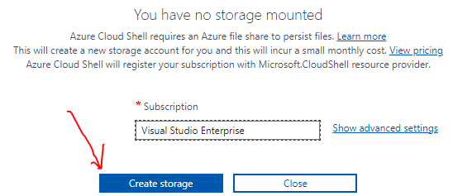

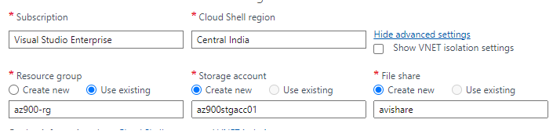

* AUTOMATIC AUTHENTICATION
  + Azure Cloud Shell automatically authenticates users to their Azure subscriptions, eliminating the need to manually authenticate every time a command is executed.
* INTEGRATED WEB-BASED EDITOR
  + Azure Cloud Shell includes a web-based code editor that allows users to create, modify, and execute scripts and code directly within the shell environment.

# CORE ARCHITECTURAL COMPONENTS

## AZURE REGIONS

* ***A*region*is a geographical area on the planet that contains at least one but potentially multiple datacenters that are nearby and networked together with a low-latency network***.

### WHY REGION IS IMPORTANT

* These regions give us the flexibility to bring applications closer to the users no matter where they are.
* Global regions provide better scalability and redundancy.

|  |  |  |
| --- | --- | --- |
|  | CASE 1: SINGLE DATA CENTER IN A REGION  Imagine if an application is deployed in a single data center in London  WHAT WOULD BE THE CHALLENGES?   * *Challenge 1*: Slow access for users from other parts of the world (high latency) * *Challenge 2*: What if the data center crashes? - ***the application will go down (low availability)*** | |
|  | CASE 2: MULTIPLE DATA CENTER IN A REGION  Let's add in one more data center in London  WHAT WOULD BE THE CHALLENGES?   * *Challenge 1*: Slow access for users from other parts of the world * *Challenge 2 (SOLVED):* What if one data center crashes? - ***Your application is still available from the other data center*** * Challenge 3: What if entire region of London is unavailable? - *Your application goes down* | |
| CASE 3: MULTIPLE REGION – MULTIPLE DATA CENTER | | |
| Let's add a new region: Mumbai.  WHAT WOULD BE THE CHALLENGES?   * Challenge 1 (PARTLY SOLVED): Slow access for users from other parts of the world.   *You can solve this by adding deployments for your applications in other regions*   * Challenge 2 (SOLVED): What if one data center crashes?   *Your application is still live from the other data centers*   * Challenge 3 (SOLVED): What if entire region of London is unavailable?   *Your application is served from Mumbai* | | ADVANTAGES:   * *High Availability* * *Low Latency* * *Global Footprint* * *Adhere to government regulations* |

### SELECTING A REGION

* *Create the Services where majority of the user resides to reduce the latency in the response.*
* *Consider the cost and availability before selecting the region for the service.*

### AZURE REGION PAIR

* Availability zones are created by using one or more datacenters. ***There's a minimum of three zones within a single region***. It's possible that a large disaster could cause an outage big enough to affect even two datacenters. That's why Azure also creates **region pairs**.
* Each Azure region is always paired with another region within the same geography (such as US, Europe, or Asia) at least 300 miles away. This approach allows for the replication of resources (such as VM storage) across a geography that helps reduce the likelihood of interruptions because of events such as natural disasters, civil unrest, power outages, or physical network outages that affect both regions at once. If a region in a pair was affected by a natural disaster, for instance, services would automatically failover to the other region in its region pair.

***Examples of region pairs in Azure are West US paired with East US and SouthEast Asia paired with East Asia.***



**ADDITIONAL ADVANTAGES OF REGION PAIRS:**

* If an extensive Azure outage occurs, one region out of every pair is prioritized to make sure at least one is restored as quickly as possible for applications hosted in that region pair.
* Planned Azure updates are rolled out to paired regions one region at a time to minimize downtime and risk of application outage.

### SOVEREIGN REGION

* In Azure, a sovereign region refers to a specific geographical area **where Azure services and infrastructure are made available to customers with specific data residency and compliance requirements**.
* **These regions are designed to cater to customers who need to store and process their data within specific national boundaries or regions for regulatory, compliance, or data sovereignty reasons**.
* We need approval to join and to create subscription.
* Not connected to Azure Public Cloud
* Adhere to different compliances standards  
    
  *Azure offers several sovereign regions to meet the unique requirements of different countries and regions around the world. Some examples of sovereign regions in Azure include:*
* AZURE GOVERNMENT
  + Azure Government is a sovereign cloud platform designed specifically for U.S. federal, state, local, and tribal government agencies and their partners.
  + It provides compliance with various U.S. government regulations, such as FedRAMP and ITAR, and enables government customers to meet their specific security and data residency requirements.
* AZURE CHINA
  + Azure China is a sovereign cloud platform operated by a local partner in collaboration with Microsoft.
  + It serves customers in China, providing Azure services that comply with China-specific regulations and data residency requirements.
* AZURE GERMANY
  + Azure Germany is a sovereign cloud platform operated by Deutsche Telekom, providing Azure services to customers in Germany.
  + It offers data residency within Germany and complies with stringent German data protection and privacy regulations.
* AZURE GOVERNMENT SECRET
  + Azure Government Secret is a sovereign cloud platform designed for U.S. federal agencies and their partners with highly classified and sensitive data.
  + It provides isolated and secure environments to meet the unique security requirements of classified workloads.

## AZURE AVAILABILITY ZONE



* Availability zones are physically separate datacenters within an Azure region.
* Each availability zone is made up of 3 more datacenters. Each datacenter is equipped with independent power, cooling, and networking.
* An availability zone is set up to be an isolation boundary. If one zone goes down, the other continues working.
* Availability zones are connected through high-speed, private fiber-optic networks.

NOTE :

* Not every region supports Availability Zones
* Not every service supports Availability Zones

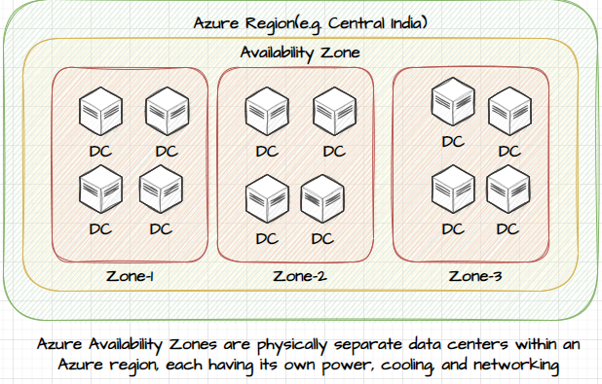

### REGION AND ZONE

* A "region" refers to a geographical area where cloud services are hosted. Each region comprises one or more data centers. Examples of Azure regions include East US, West Europe, and Southeast Asia.
* **On the other hand, an "Availability Zone" is a specific set of data centers within an Azure region**. These zones are designed to be isolated from each other to provide redundancy and fault tolerance. Deploying resources across multiple Availability Zones helps ensure high availability and resilience to failures.
* In summary, a region is a broader geographical area, while an Availability Zone is a specific, isolated part of that region for enhanced reliability. Utilizing both can help enhance the overall availability and reliability of your cloud applications.

### TYPES OF AVALIBILITY ZONE SERVICES

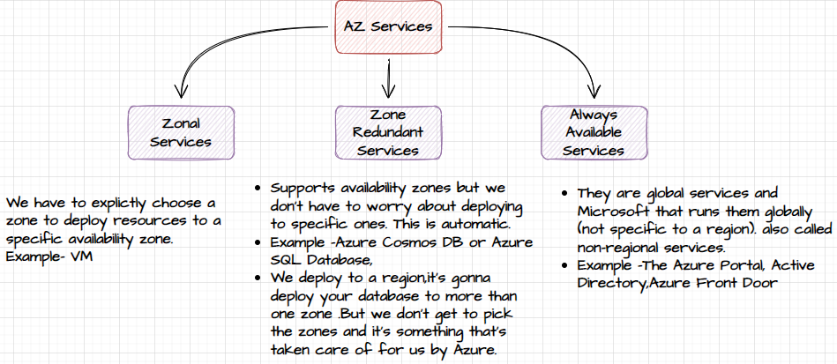

## RESOURCES AND RESOURCE GROUP

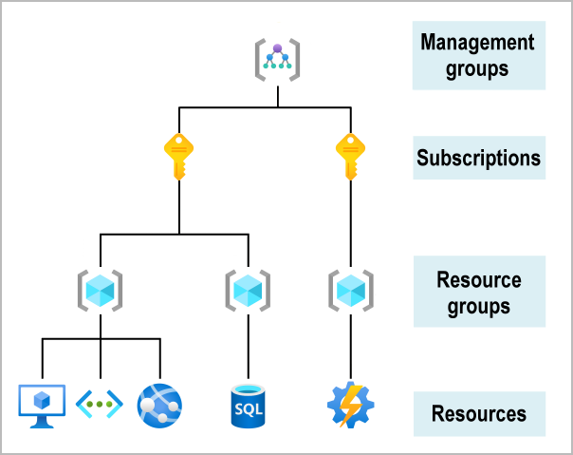

### RESOURCES

* Resources are instances of services that we create, like virtual machines, storage, or SQL databases.
* Resources can be created using Azure Portal, CLI, PowerShell, ARM template & Biceps
* Resource has to be deployed to a region having a name (which sometimes has to be unique and sometimes not).
* Resources are associated to just one subscription.

### RESOURCE GROUP

|  |  |
| --- | --- |
| Conceptual image showing a resource group box with a function, VM, database, and app included.  **LIFE CYCLE**   * If you delete a resource group, all resources contained within it are also deleted. * Resource groups make it easy to remove a set of resources all at once.   **AUTHORIZATION**   * **Resource groups are also a scope for applying role-based access control (RBAC) permissions.** * By applying RBAC permissions to a resource group, we can ease administration and limit access to allow only what's needed. | * A resource group is a logical container for resources deployed on Azure. * All resources must be in a resource group, and a resource can only be a member of a single resource group. * Resources can be moved between resource groups with some services having specific limitations or requirements to move. * Resource groups can't be nested. * Before any resource can be provisioned, we need a resource group for it to be placed in. * A resource group can contain resources that are located in different regions. * A resource group can be used to manage access control for administrative actions. You can give access to an entire resource group, including the resources in it. * When a resource group is removed or deleted, all the resources within it are deleted with it, but the delete request fails, it may be because there's a lock on the resources or resource group. Even if you didn't manually lock a resource group, it may have been automatically locked by a related service**. Or the deletion can fail if the resources are connected to resources in other resource groups that aren't being deleted. For example, you can't delete a virtual network with subnets that are still in use by a virtual machine.** |

#### CREATING A RESOURCE GROUP

|  |  |
| --- | --- |
| * All the resources are tied to a subscription for billing aspects. * The resource group must associate to a region. * ***The resource can only be a part of a one subscription.*** |  |

#### CREATING A RESOURCE GROUP USING AZURE CLI AND POWERSHELL

#### MOVING THE RESOURCES ACROSS RESOURCE GROUP

|  |  |
| --- | --- |
|  | * Resources can be moved from one resource group to another. Note – Moving the resources does not change the location of the resource – it has nothing to do the region of resource group. |

#### MOVING THE RESOURCES ACROSS SUBSCRIPTION

* We can move the resource across the subscription.
* When we want to move the resource to another subscription, then we must move its dependent resources as well onto that subscription.
* For example, for a VM, this includes disk, Azure virtual network, the public IP address, etc.
* Go the resource group 🡪 Select all the dependent resources 🡪 Move to another subscription.

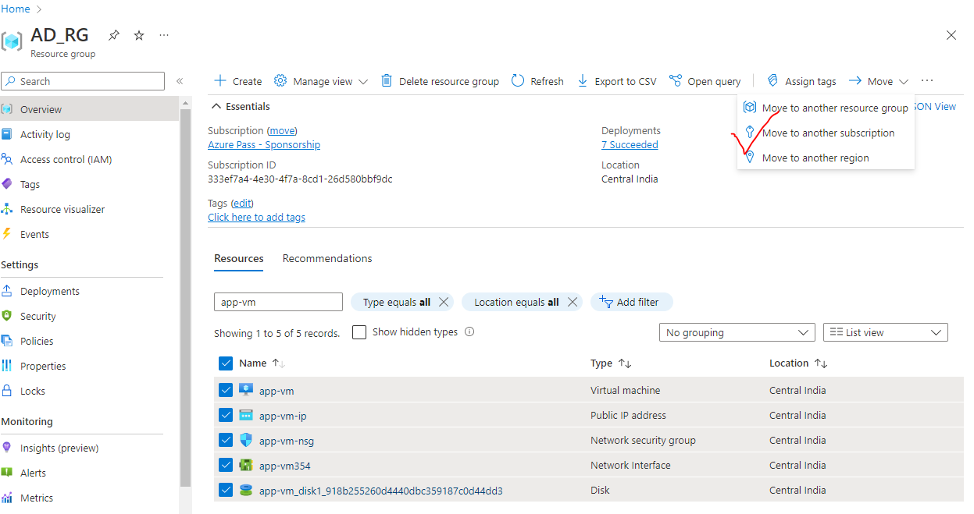

#### RESOURCE TAGS

|  |  |
| --- | --- |
|  | * Resource tags are used to organize the resources. * Each tag consists of a name on a value pair. For example, if we want to organize the resources which belong to a specific department in an organization – we can make use of tags. * To create a resource tag 🡪 Go to the resource. * Using Tags – we can be able to filter the resources tags. * We can get the cost analysis of the resources based on tags. For example – Cost analysis of tags -which belongs to a department. |
|  |

## SUBSCRIPTION

* Azure subscription is an active agreement between Microsoft and its users. This agreement provides users the needed access to avail the services and resources offered by Microsoft Azure.
* ***User can have multiple Azure subscription linked to its Azure Account***.



### TYPES OF AZURE SUBSCRIPTION

* **FREE TRIAL SUBSCRIPTION**
* **PAY AS YOU GO SUBSCRIPTION**
* **VISUAL STUDIO SUBSCRIPTION**
* **STUDENT SUBSCRIPTION**
* **ENTERPRISE AGREEMENT SUBSCRIPTION**
* **CLOUD SOLUTION PARTNER SUBSCRIPTION**

## MANAGEMENT GROUP

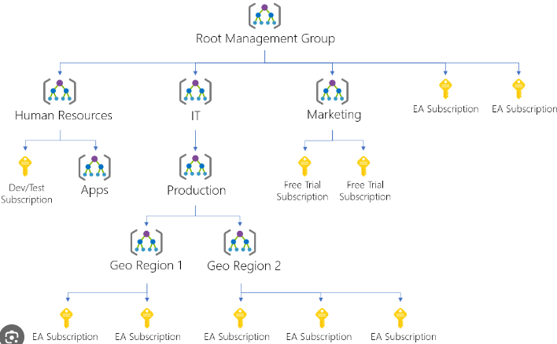

Using management group, we can

1. GROUP SUBSCRIPTION

* Take action across subscriptions in bulk – useful for large organizations having many subscriptions.

1. ORGANIZE

* In Microsoft Azure, Management Groups are a hierarchical organizational construct that helps in organizing and managing resources at scale.
* *They provide a way to group multiple subscriptions together and apply consistent policies, access controls, and governance across those subscriptions. All subscriptions in a management group automatically inherit the conditions applied to the management group.*
* **There is no charge applied on management group**

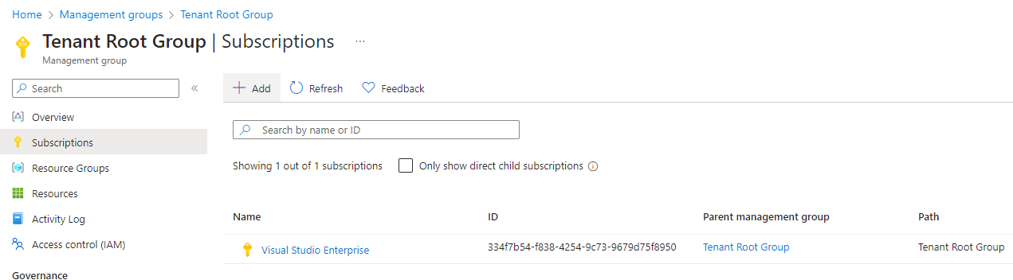

KEY FEATURES AND BENEFITS OF USING MANAGEMENT GROUPS IN AZURE:

* HIERARCHICAL STRUCTURE
  + Management Groups allow us to create a hierarchical structure, like a folder tree, to organize our subscriptions and resources.
  + We can create multiple levels of management groups and organize them based on our organizational structure, projects, departments, or any other logical grouping.
* POLICY AND ACCESS CONTROL
  + By applying policies at the management group level, we can enforce consistent governance and compliance across multiple subscriptions.
  + Policies defined at a higher level are inherited by the management groups and subscriptions underneath, ensuring adherence to regulatory requirements, security standards, and best practices.
* ROLE-BASED ACCESS CONTROL (RBAC)
  + Management Groups provide a way to assign RBAC roles at higher levels, which are then inherited by the management groups and subscriptions within.
  + This allows us to manage access controls at a centralized level and ensure consistent security permissions across the Azure resources.
* SIMPLIFIED RESOURCE MANAGEMENT
  + With Management Groups, we can perform management tasks, such as resource tagging, monitoring, and cost management, across multiple subscriptions in a unified manner.
  + This simplifies the management of resources and provides a holistic view of your Azure estate.
* BULK OPERATIONS
  + Management Groups allow us to perform bulk operations on subscriptions and resources within a management group.
  + For example, we can apply a policy or change access controls across multiple subscriptions at once, saving time and effort in managing individual resources.
* DELEGATION AND SCALABILITY
  + Management Groups enable delegation of management responsibilities to different teams or departments within your organization.
  + We can assign appropriate permissions to different management groups, allowing teams to manage their own subscriptions and resources, while still maintaining centralized governance and control.

## MANAGING / CREATING BUDGET

* Budgets in Cost Management helps us proactively inform others us about the spending to manage costs and monitor how spending progresses over time.
* We can configure alerts based on our actual cost or forecasted cost to ensure that we are spending within your organizational spending limit. Notifications are triggered when the budget thresholds we have created are exceeded.
* Resources are not affected, and your consumption isn't stopped. You can use budgets to compare and track spending as you analyze costs.

### SETTING UP BUDGET

1. Go to Subscription 🡪 Budgets🡪 Add

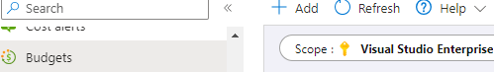

|  |  |
| --- | --- |
|  |  |

### RESOURCE LOCKING

* Looking resources helps ensure users don’t accidently delete or modify resources.

#### TYPES OF RESOURCE LOCKS

|  |  |
| --- | --- |
| ***CanNotDelete*** | Authorized users can read and modify the resources, but they can’t delete the resources |
| ***ReadOnly*** | * Authorized users can read the resources, but they can’t delete or update the resources * For example – for the VM having ready only lock- We cannot be able start or stop the VM – because read only lock does not even allow to update the properties of the resource.(status) |

#### LAB – LOCKING RESOURCES

|  |  |
| --- | --- |
|  | ***Lock can be applied on resouce level , resource group level and subscription level***   * Any lock on resource level will lock the given resources. * But a lock on resource group level it will inherited by all the resources in that resource group. * But a lock on subscriptionlevel it will inherited by all the resources in that subscription. * To remove the lock on any resource – we have to delete the lock itself |
| LOCk applied on Resource Group level | Inherited Lock (by the resources) |

## AZURE RESOURCE MANAGER (ARM)



### HOW ARM WORKS?





* When a user sends a request from any of the Azure tools, APIs, or SDKs, (***Note – From PowerShell & CLI the request to ARM goes via SDK***)
* When a Resource Manager receives the request for a resource. It first authenticates and authorizes the request.
* And if we have required permission - ARM sends the request to the Resource Providers

**NOTE –**

* + The resource provider details can be found in **Subscription 🡪 Resource Provider**
  + Example: if we are requesting to create a Storage Account. The request will go to **ARM 🡪 Microsoft.Storage(Provider). Hence - The Resource Provider is one which do the heavy lifting.**

#### AZURE RESOURCE PROVIDER



## AZURE SERVICES

Microsoft Azure offers various web-scale cloud services that are grouped together based on different business usage. These groups are called domains. Some of the main domains are listed below



### COMPUTE SERVICES





### NETWORKING





#### WHAT IS THE DIFFERENCE BETWEEN LOAD BALANCER AND APPLICATION GATEWAY?

|  |  |
| --- | --- |
|  | * The Application Gateway work at application layer (Layer 7) but load balancer works at transport layer(Layer 4) * Application Gateway is used om top of load balancer to make routing based decision. Means we can make decision of routing the traffic based on type of request |

##### EXAMPLE

* Lets say – we have applicationwhere we have VM pools dedicated for “image” upload and another VM pool which handles “form” submission.
* Here we can distribute the traffic among the VMs using load balancer – but which type of request (image upload or form submission) will go which VM is decided by Application Gateway.



### STORAGE SERVICE







### DATABASE





# AZURE CORE SERVICES

Commomly used categories of Azure Services

1. COMPUTE
2. NETWORKING
3. STORAGE
4. MOBILE
5. DATABASES
6. WEB
7. INTERNET OF THINGS (IOT)
8. BIG DATA
9. AI
10. DEVOPS

**Azure Services** : <https://docs.microsoft.com/en-us/learn/modules/intro-to-azure-fundamentals/tour-of-azure-services>



# AZURE ADVISOR

* Azure Advisor **offers recommendations and best practices for optimizing Azure resources and improving the performance, security, and reliability of Azure deployments**.
* It provides **actionable insights** based on Azure best practices and usage patterns, helping us optimize the resources, reduce costs, and enhance the overall efficiency of your Azure environment.

FEATURES AND BENEFITS OF AZURE ADVISOR

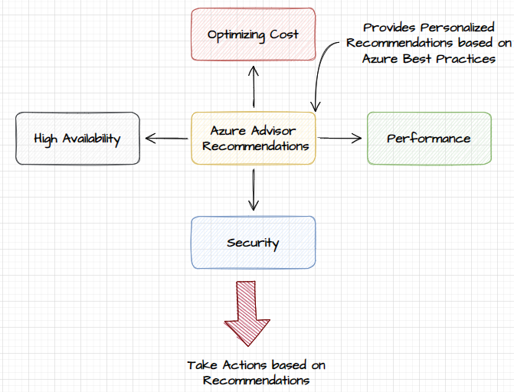

* COST OPTIMIZATION
  + Azure Advisor provides recommendations to help us to optimize your resource usage and reduce costs.
  + **It suggests rightsizing underutilized virtual machines, identifying idle resources, and recommends cost-effective purchasing options like reserved VM instances and Azure Hybrid Benefit**.
* PERFORMANCE IMPROVEMENT
  + Azure Advisor evaluates the resource configurations and provides recommendations to improve the performance of Azure deployments.
  + It offers insights on optimizing network latency, disk performance, virtual machine sizes, and configuring load balancers for better performance.
* SECURITY ENHANCEMENTS
  + Azure Advisor assesses our resource configurations against Azure security best practices and provides recommendations to enhance the security of your deployments.
  + It suggests actions such as *enabling encryption, implementing network security groups, configuring firewalls, and improving identity and access management.*
* HIGH AVAILABILITY
  + Azure Advisor offers recommendations to improve the availability and reliability of the applications and services.
  + It suggests configuring availability sets, using availability zones or regions, and implementing backup and disaster recovery strategies to minimize downtime.
* CONTINUOUS MONITORING
  + Azure Advisor continuously monitors your Azure resources and periodically provides updated recommendations based on changes in our environment or new Azure best practices.

# AZURE MANAGEMENT AND GOVERNANCE

## PRICING STRUCTURE

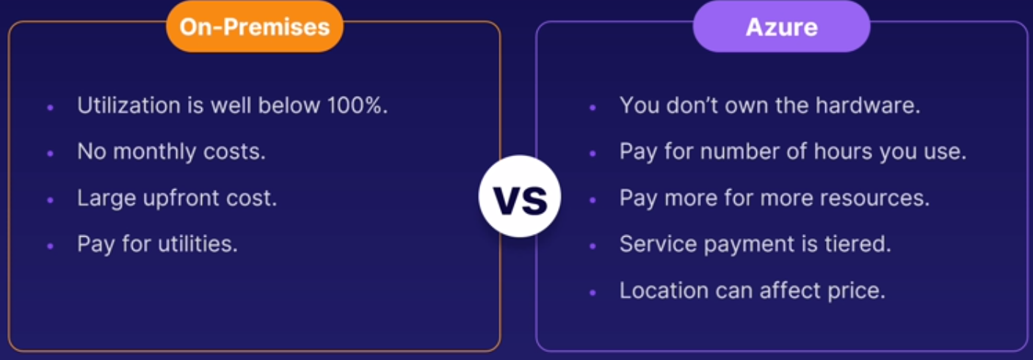

## AZURE COST MANAGEMENT

* Azure Cost Management is a tool provided by Microsoft that helps organizations monitor, manage, and optimize their Azure cloud costs.
* It enables users to gain insights into their usage and spending, identify cost-saving opportunities, and set budget and spending limits.
* The Cost Management tool is completely free of charge for all subscription types

KEY FEATURES AND FUNCTIONALITIES OF AZURE COST MANAGEMENT:

* COST VISIBILITY
  + Azure Cost Management provides a comprehensive view of your Azure spending and usage across subscriptions, resource groups, and services. It offers detailed reports, dashboards, and interactive charts to visualize and analyze your cost data.
* COST ANALYSIS
  + The tool enables you to analyze your Azure costs by different dimensions such as resource type, region, and tags. It helps you identify cost drivers and optimize spending by understanding which resources are consuming the most resources and incurring the highest costs.
* BUDGETING AND ALERTS
  + Azure Cost Management allows you to set budget limits for your Azure spending and receive alerts when you approach or exceed those limits. It helps you proactively manage your costs and avoid unexpected overages.
* COST OPTIMIZATION RECOMMENDATIONS
  + The tool provides recommendations to optimize your Azure costs based on your usage patterns and resource configurations. These recommendations can include rightsizing virtual machines, deleting unutilized resources, or switching to reserved instances for cost savings.
* AZURE ADVISOR INTEGRATION
  + Azure Cost Management integrates with Azure Advisor, which provides intelligent recommendations for improving the performance, security, and reliability of your Azure resources. This integration helps you make informed decisions that balance cost optimization with other important considerations.
* COST ALLOCATION AND CHARGEBACK
  + Azure Cost Management allows you to allocate costs to different departments, teams, or projects within your organization.

## PRICING FACTORS

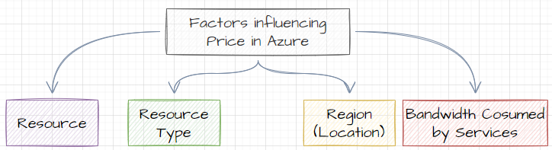

### AZURE BILLING ZONES

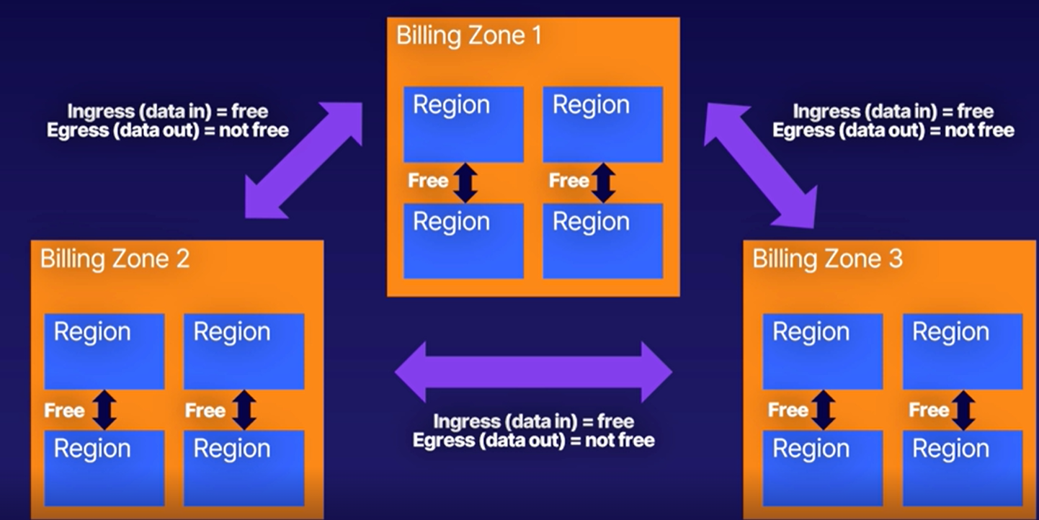

* Azure has three billing zones in the world and each of these zones include many Azure regions.
* Any data transfer between Azure services located in the same zone is free.
* Any data transfer between two different billing zones is charged. This is also called ingress, data in, and egress, data out, data. ***Ingress data is always free, but egress data (so that's data going out) has a cost with it when it is transmitted between two different billing zones.***

## PRICING CALCULATOR

* The Azure Pricing Calculator is a tool provided by Microsoft Azure that allows us **to estimate and calculate the costs of using various Azure services and resources**.
* It helps us to understand the pricing structure and provides an estimate of the monthly costs based on our usage requirements.
* URL : <https://azure.microsoft.com/en-us/pricing/calculator/>

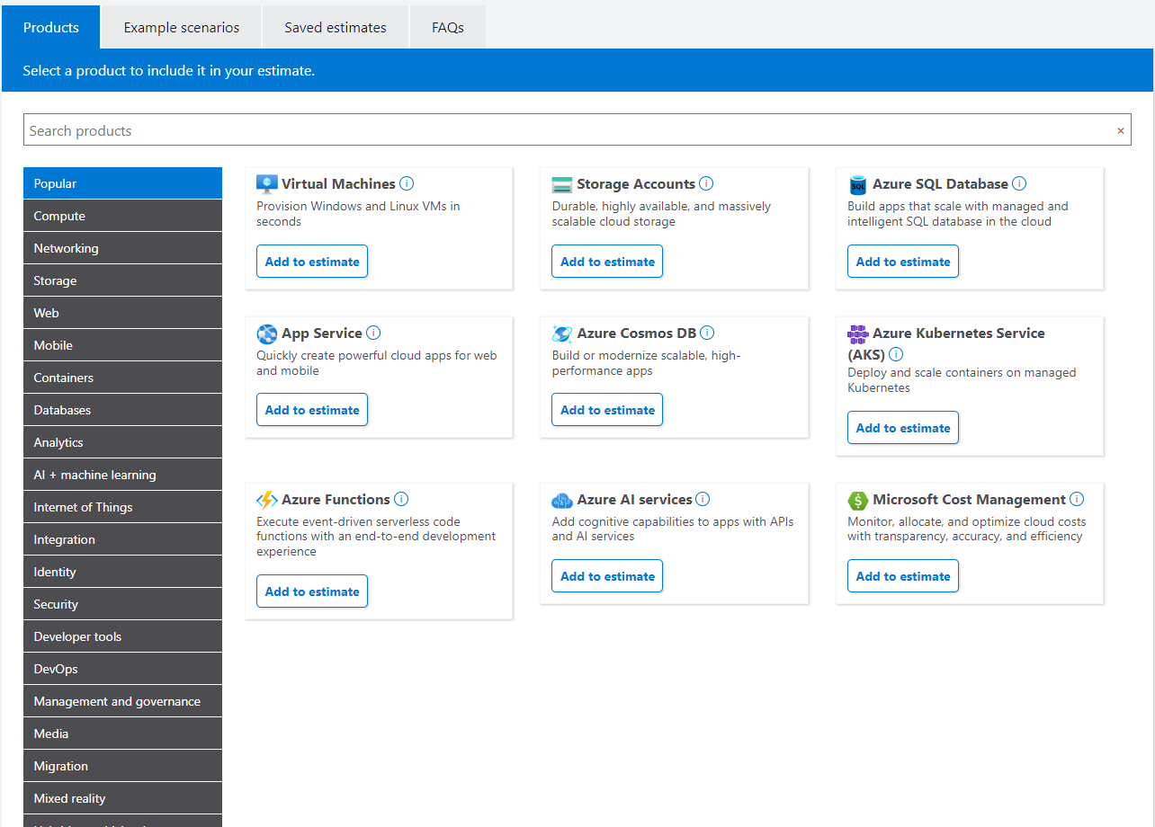

## TOTAL COST OWNERSHIP CALCULATOR

* The Total Cost of Ownership (TCO) Calculator is a tool that helps organizations estimate the overall costs associated with implementing and operating a particular technology solution or system over a defined period.
* TCO considers the upfront costs but also the ongoing expenses, maintenance, and support costs.
* Microsoft offers a TCO Calculator specifically for comparing the costs of running workloads on-premises versus in the cloud using Azure. This tool helps organizations assess the potential cost savings and benefits of migrating their infrastructure or applications to Azure.
* URL : <https://azure.microsoft.com/en-us/pricing/tco/calculator/>

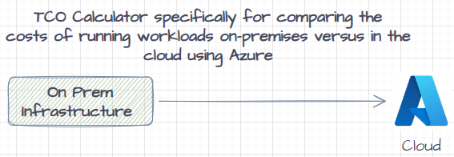

## BEST PRACTICES – COST MANAGEMENT

1. SET BUDGET LIMITS
   1. Establish budget limits to control the Azure spending.
   2. Set realistic budgets based on historical data and adjust them as needed.
   3. Azure Cost Management allows us to set budget alerts to receive notifications when we approach or exceed our defined spending limits.
2. RIGHTSIZE RESOURCES
   1. Continuously evaluate the resource usage and right-size the virtual machines and other Azure resources.
   2. Downsizing or using lower-cost alternatives can significantly reduce costs while still meeting the performance requirements.
3. LEVERAGE RESERVED INSTANCES
   1. Utilize Azure Reserved Virtual Machine Instances for predictable workloads with long-term commitments.
   2. Reserved Instances provide substantial cost savings compared to pay-as-you-go rates.

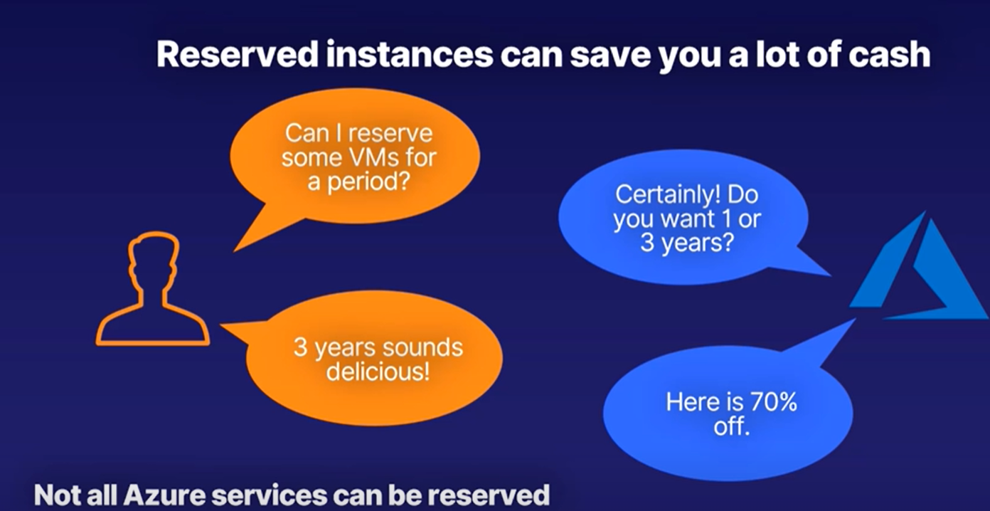

1. USE AZURE HYBRID BENEFIT
   1. If we have active software assurance, take advantage of the Azure Hybrid Benefit to save on Windows Server and SQL Server licensing costs when running them in Azure.
2. OPTIMIZE STORAGE COSTS
   1. Optimize the Azure storage costs by regularly reviewing and deleting unused or unnecessary data.
   2. Utilize features like Blob Storage lifecycle management to automatically move or delete data based on defined policies.
3. UTILIZE SERVERLESS TECHNOLOGIES
   1. Consider leveraging serverless technologies like Azure Functions or Logic Apps for certain workloads.
   2. Serverless offerings scale dynamically and can be more cost-effective for sporadic or low-traffic workloads.
4. TAKE ADVANTAGE OF SPOT INSTANCES
   1. Consider using Azure Spot Virtual Machines for fault-tolerant workloads that can handle interruptions. Spot VMs offer significant cost savings compared to regular on-demand pricing.
5. IMPLEMENT RESOURCE TAGGING:
   1. Implement consistent and meaningful resource tagging practices.
   2. Tags can help you track and categorize costs by department, project, or other criteria, making it easier to allocate costs and identify areas for optimization.
6. REGULARLY REVIEW AND OPTIMIZE
   1. Continuously review and optimize your Azure resources, services, and spending.
   2. Regularly assess your environment, apply cost optimization recommendations provided by Azure Advisor, and stay up to date with the latest cost management best practices.

## BUDGETS

* In Azure, budgets are a feature that allows us **to set spending limits and receive notifications when the usage or costs exceed the defined thresholds**.
* Budgets help us in monitoring and managing Azure spending to avoid unexpected expenses and maintain control over resources.

### CREATING BUDGETS

* Go to subscription 🡪 Budget 🡪 Add Budgets
* In the below example we are creating a budget that will send an email notification when the cost reaches the 80% (**6400**) of the budget amount (**8000**)

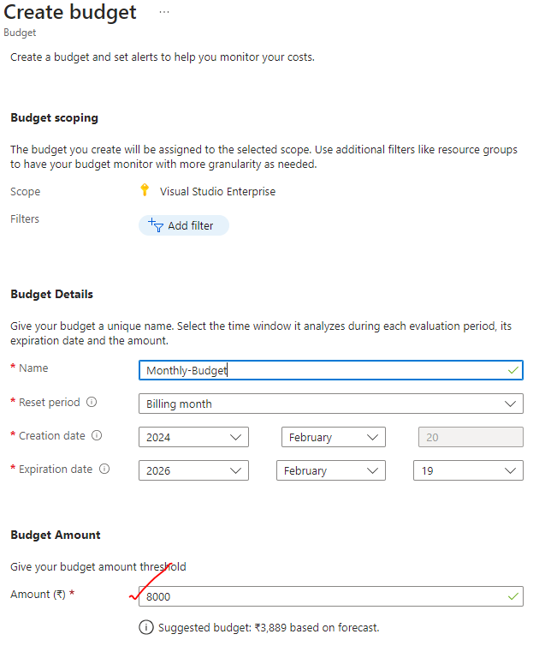

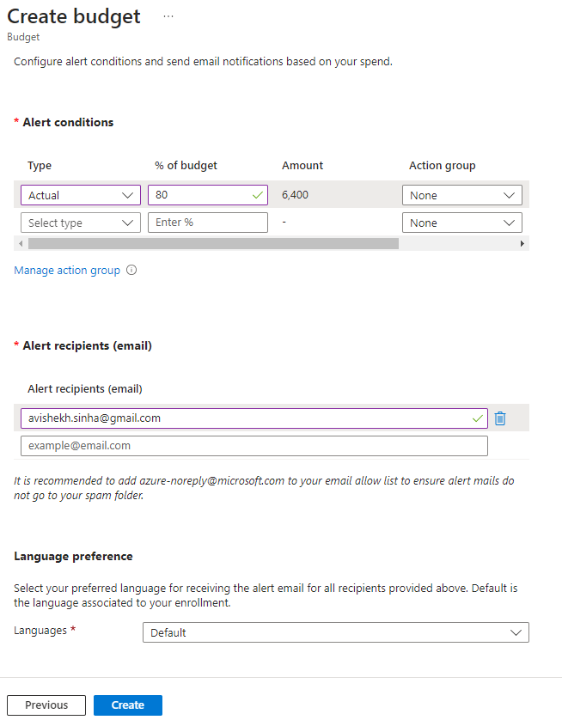

## AZURE SUPPORT PLANS

* URL : <https://azure.microsoft.com/en-us/support/plans>

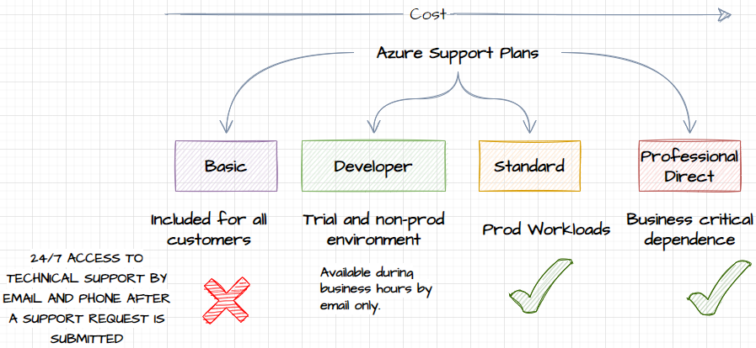

## AZURE SERVICE LEVEL AGGREMENT

* Azure provides Service Level Agreements (SLAs) to ensure a certain level of service availability and performance for its customers.
* SLAs outline the commitments and guarantees that Microsoft Azure makes regarding the reliability and performance of its services.
* URL: <https://www.microsoft.com/licensing/docs/view/Service-Level-Agreements-SLA-for-Online-Services?lang=1>

#### MONTHLY UPTIME

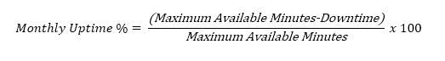

* If Microsoft unable to give the Monthly uptime as mentioned in the SLA of a given service for example in case of VM the following Service Levels and Service Credits are applicable to Customer’s use of Virtual Machines deployed across two or more Availability Zones in the same region:

| Uptime Percentage | Service Credit |
| --- | --- |
| < 99.99% | 10% |
| < 99% | 25% |
| < 95% | 100% |

## SERVICES IN PREVIEW

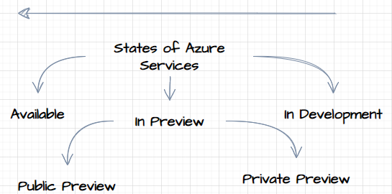

|  |  |
| --- | --- |
| * PRIVATE PREVIEW   + **Private preview is an early access program for select customers who are invited to test and provide feedback on new Azure services or features that are still in development.**   + These previews are typically limited to a smaller group of customers who have expressed interest or meet specific criteria.   + During the private preview, Microsoft actively seeks feedback to understand the usability, performance, and functionality of the service before making it generally available. * PUBLIC PREVIEW   + Public preview, also known as "preview" or "beta," is a broader release of a new Azure service or feature to a larger audience.   + It allows customers to try out the service and provide feedback to help Microsoft refine and improve it before it reaches general availability.   + Public previews are open to all Azure customers, and customers can opt to use and test the service in their own environments. |  |

* It's important to note that services in preview may still have limitations, known issues, or frequent updates as they are still being refined based on customer feedback. Those services will have no SLA associated with it, hence not recommended to be used on PROD
* **To participate in private or public previews, customers can typically register their interest through the Azure portal or by following specific instructions provided by Microsoft for the respective service or feature.**

## MICROSOFT CLOUD ADOPTION FRAMEWORK

* <https://learn.microsoft.com/en-us/azure/cloud-adoption-framework/overview>
* **The Microsoft Cloud Adoption Framework (CAF) is a set of guidance and best practices provided by Microsoft to help organizations plan, implement, and govern their cloud adoption journey**. It offers a structured approach and framework to ensure a successful and well-managed transition to the cloud.
* The CAF provides a comprehensive set of documentation, tools, and resources that cover various aspects of cloud adoption, including strategy, planning, readiness, migration, and ongoing operations.
* It helps organizations align their business goals and technical requirements with the capabilities and benefits of the Microsoft Azure cloud platform.

**KEY COMPONENTS OF THE MICROSOFT CLOUD ADOPTION FRAMEWORK:**

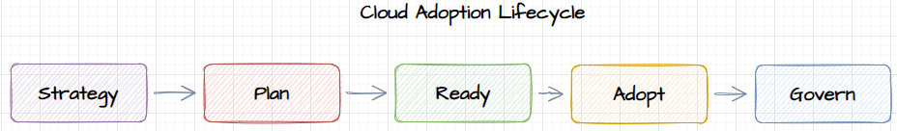

* STRATEGY
  + The CAF helps organizations define their cloud adoption strategy by considering business goals, compliance requirements, security, governance, and cost management.
* PLAN
  + It provides guidance on creating a detailed roadmap and project plan for migrating workloads, applications, and data to Azure.
  + This includes assessing current IT assets, identifying dependencies, and prioritizing migrations.
* READY
  + The CAF helps organizations prepare their IT environment, resources, and teams for cloud adoption.
  + It covers areas like training, skills development, establishing governance policies, and setting up cloud management tools.
* ADOPT
  + This phase focuses on executing the migration plan, carrying out workload assessments, performing data migration, and deploying applications and services in Azure.
  + It provides guidance on using Azure services effectively and optimizing workloads for the cloud.
* GOVERN
  + The CAF emphasizes the importance of ongoing governance and management of cloud resources.
  + It covers topics like monitoring, security, compliance, cost optimization, and establishing operational processes.

## SERVICE TRUST PORTAL

* The Service Trust Portal is a Microsoft Azure website that provides customers with information and resources related to the privacy, compliance, and security of Microsoft cloud services.
* It is designed to help customers understand how Microsoft implements and maintains security, privacy, and compliance controls to protect customer data.

FEATURES AND INFORMATION AVAILABLE ON THE SERVICE TRUST PORTAL:

* COMPLIANCE DOCUMENTATION
  + The portal provides access to compliance-related documentation, including audit reports, certifications, and attestations for Microsoft cloud services.
  + This includes information on compliance with standards such as ISO, SOC, GDPR, HIPAA, and more.
* PRIVACY CONTROLS
  + It offers information on how Microsoft handles and protects customer data, including privacy controls, data retention policies, and data subject requests.
  + This helps customers understand the privacy commitments and practices of Microsoft cloud services.
* SECURITY BASELINES
  + The portal includes security baselines and best practices for securing Azure services and infrastructure.
  + It provides guidance on security controls, threat protection, data encryption, identity and access management, and more.
* RISK ASSESSMENTS
  + Customers can find information on risk assessments, threat intelligence, and incident response capabilities of Microsoft cloud services.
  + This helps customers assess the security posture of the services they are using or planning to use.
* The Service Trust Portal is a valuable resource for customers who need to understand the security, privacy, and compliance aspects of Microsoft cloud services. It enables organizations to assess the suitability of Microsoft cloud services for their specific regulatory and compliance requirements.

## AZURE BLUEPRINT

## AZURE POLICY